Raans: Code of Conduct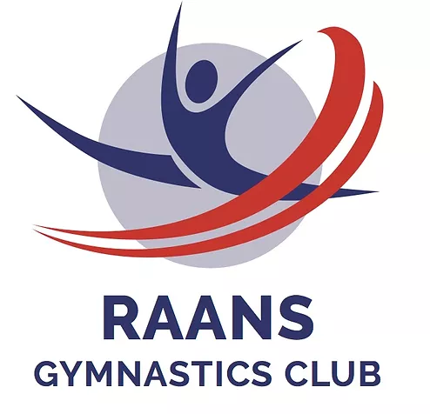
Safeguarding is everyone’s responsibility and it is important that organisations work together to protect and promote the well-being of all our members.
Raans believes it is important that members, coaches, administrators and parents associated with the club should, at all times, show respect and understanding for the safety and welfare of others.
Members are encouraged to be open at all times and share any concerns or complaints that they may have about any aspect of the club with the Club Welfare Officer, Suzanne Westlake.

As a member of Raans Gymnastics Club members are expected to abide by the following club rules:
- All members must participate within the rules and respect coaches, judges and their decisions.
- All members must respect opponents and fellow club members.
- Members should keep to agreed timings for training and competitions or inform their coach, or if they are going to be late or unable to attend.
- Members must wear suitable attire for training and events as agreed with the coach. Keep all long hair tied back. Remove all body jewellery.
- Members must pay any fees for training or events promptly.
- Members must not smoke, consume alcohol or take drugs of any kind whilst representing the club at competitions or other events.
- Members should treat all equipment with respect.
- Members must inform the head coach of any injuries or illness they may have before the warm-up begins.
- Members should not eat or chew gum during a session.
- Members must not use bad language.
- Members should remain with coaches at the end of a session until collected by their parent or guardian

In addition, parents are requested to:
- Learn the rules and participate within them.
- Discourage challenging or any arguing with officials.
- Help your child to recognise good performance, not just results.
- Set a good example by recognising good sportsmanship and applauding the good performances of all.
- Never force your child to take part in sport or punish/belittle a child for poor performance or making mistakes.
- Always ensure your child is dressed appropriately for the activity and has plenty to drink.
- Keep the club informed if your child is ill or unable to attend sessions.
- Endeavour to establish good communications with the club, coaches and officials for the benefit of all.
- Share any concerns or complaints about any aspect of the club through the approved channels.
- Use correct and proper language at all times.
- Always collect your child promptly at the end of a session.
- Above all, support your child's involvement and help them to enjoy their sport.

